**PIZZA SALES SQL QUERIES**

1. **KPIs**
2. Total Revenue

SELECT SUM(total_price) AS Total_Revenue FROM pizza_sales

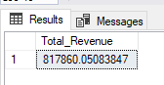

1. Average order value

SELECT SUM(total_price) / COUNT(DISTINCT order_id) AS Avg_order_value FROM pizza_sales

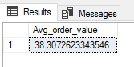

1. Total Pizzas sold

SELECT SUM(quantity) AS Total_pizzas_sold FROM pizza_sales

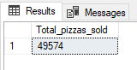

1. Total orders

SELECT COUNT(DISTINCT order_id) AS Total_orders FROM pizza_sales

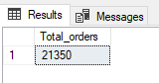

1. Average pizzas per order

SELECT CAST(CAST(SUM(quantity) AS DECIMAL(10,2)) / CAST(COUNT ( DISTINCT order_id) AS DECIMAL(10,2)) AS DECIMAL(10,2))

AS Avg_pizzas_per_order FROM pizza_sales

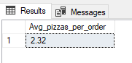

1. **Charts**
2. Daily trend for total orders

SELECT DATENAME(DW, order_date) AS order_day, COUNT(DISTINCT order_id) AS Total_orders FROM pizza_sales

GROUP BY DATENAME(DW, order_date)

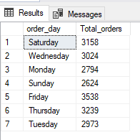

1. Monthly trend for total orders

SELECT DATENAME(MONTH, order_date) AS order_day, COUNT(DISTINCT order_id) AS Total_orders FROM pizza_sales

GROUP BY DATENAME(MONTH, order_date)

ORDER BY Total_orders DESC

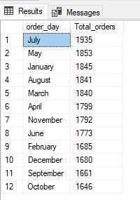

1. Hourly trend for orders

SELECT DATEPART(HOUR,order_time) AS Order_hours, COUNT(DISTINCT order_id) AS Total_orders FROM pizza_sales

GROUP BY DATEPART(HOUR,order_time)

ORDER BY DATEPART(HOUR,order_time)

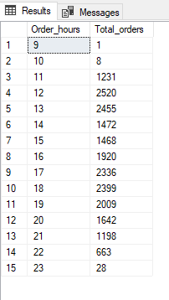

1. Percentage of sales by Pizza category

SELECT pizza_category, SUM(total_price) AS Total_price,SUM(total_price) * 100/ (SELECT SUM(total_price) FROM pizza_sales) AS PCT

FROM pizza_sales

GROUP BY pizza_category

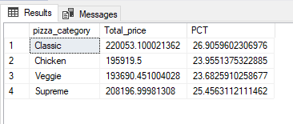

1. Percentage of sales by pizza size

SELECT pizza_size, CAST(SUM(total_price) AS DECIMAL(10,2)) AS Total_price,CAST(SUM(total_price) * 100/ (SELECT SUM(total_price) FROM pizza_sales) AS DECIMAL(10,2)) AS PCT

FROM pizza_sales

GROUP BY pizza_size

ORDER BY PCT DESC

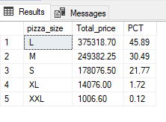

1. Top 5 pizzas by revenue

SELECT TOP 5 pizza_name, SUM(total_price) AS Total_revenue FROM pizza_sales

GROUP BY pizza_name

ORDER BY Total_revenue DESC

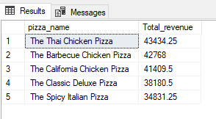

1. Bottom 5 pizzas by revenue

SELECT TOP 5 pizza_name, SUM(total_price) AS Total_revenue FROM pizza_sales

GROUP BY pizza_name

ORDER BY Total_revenue ASC

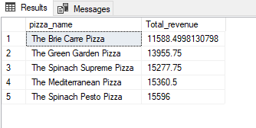

1. Top 5 Pizzas by quantity

SELECT TOP 5 pizza_name, SUM(quantity) AS Total_Quantity FROM pizza_sales

GROUP BY pizza_name

ORDER BY Total_Quantity DESC

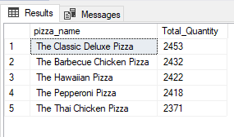

1. Bottom 5 pizzas by quantity

SELECT TOP 5 pizza_name, SUM(quantity) AS Total_Quantity FROM pizza_sales

GROUP BY pizza_name

ORDER BY Total_Quantity ASC

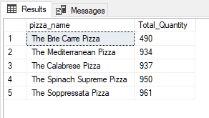

**NOTE**

If you want to apply Month, Week or Quarter filters to the above queries you can use WHERE clause. Below are some examples:

SELECT pizza_category, SUM(total_price) AS Total_price,SUM(total_price) * 100/ (SELECT SUM(total_price) FROM pizza_sales WHERE MONTH(order_date) = 1) AS PCT

FROM pizza_sales

WHERE MONTH(order_date) = 1

GROUP BY pizza_category

MONTH(order_date)=1 indicates the output is for the month of January

SELECT pizza_category, SUM(total_price) AS Total_price,SUM(total_price) * 100/ (SELECT SUM(total_price) FROM pizza_sales WHERE DATEPART(QUARTER, order_date) = 1) AS PCT

FROM pizza_sales

WHERE DATEPART(QUARTER, order_date) = 1

GROUP BY pizza_category

DATEPART(QUARTER, order_date) = 1 indicates the output is for Quarter 1